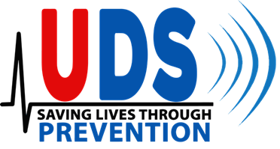Local 22 Philadelphia Health Plan

Ultrasound Health Screening

**TO:** ACTIVE and RETIREES MEMBERS of Local 22 Health Plan   
**FROM:** Jerry Kots  
 **RE:** Ultrasound-based Cardiovascular and Cancer Screening Event  
 **DATE:** April 9th, 2024

As a result of our continued commitment to the Health and Wellness of our members, Local 22 Health Plan is hosting an UltrasoundScreening **Mondays to Fridays** starting **Monday, May 6th, 2024, to Friday, March 24th, 2024 from 7:00 AM to 3:00 PM. *If you went through this service over the last 2 years, then you will not be eligible to participate this year.***

Local 22   
415 N.5th Street   
Philadelphia, PA, 19123-4095

United Diagnostic Services will be conducting Early Detection Diagnostic Testing, which has proven successful in identifying actionable pathologies to improve overall health as well as early detection for cancer and cardiovascular issues. Early detection has had a significant impact on helping prevent and reverse potential future catastrophic events. All tests are ultrasound-based and therefore painless.

**All tests are ultrasound based and therefore painless, and non-invasive. Tests include an Echocardiogram, Carotid, Abdominal Aorta, Thyroid, Liver, Spleen, Bladder, Kidney, and Testicular. This screen also includes an Exterior Pelvic scan for females. The examination will take approximately 30 min to complete.**

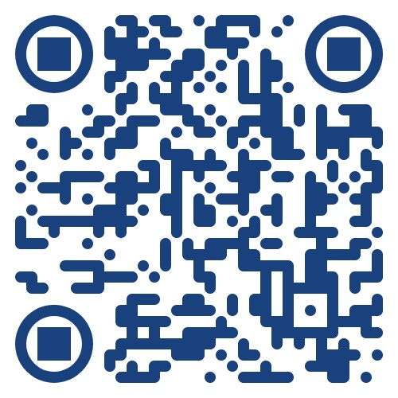*Fasting for at least 6 hours is required for the screening and you must pre-register to participate. Results will be issued via email 7 to 10 business days after testing. Be sure to use the email & phone number you’d like to receive updates when registering.*

**Pre-registration is required.** **To schedule your appointment:**

1. Go to (click here) [Scheduling Link](https://udshealth.as.me/?calendarID=9883164) or Scan QR Code (https://udshealth.as.me/?calendarID=9883164)
2. Click on “Choose Appointment”
3. Select your desired appointment date/time and
4. click “Continue”
5. Enter required information: First & Last Name, phone number,

And email address.

1. Enter additional information as necessary.
2. Click “Complete Appointment”
3. You will get a welcome email and appointment confirmation email with exam instructions.

**You can set up an account to log in and adjust your account or appointment.**

**For questions, please call or text our Main Number at (646) 553-5803**